Engr421 HW-3

Navie Baye’s Classifier

Doğukan Soyuyüce

69331

***Objectives of the homework :***

We are asked to implement a parametric classification in that homework. We are given a real life letter dataset which consist of 195 letters. We have to classify these letters into 5 separate classes using parametric classification with Bernoulli.

***1-)*** I firstly divided the given dataset consists of 195 data points into test and train sets. Secondly I turned my pandas dataframe datasets into numpy array , in order to be able to use them in my algorithm and multiplications. 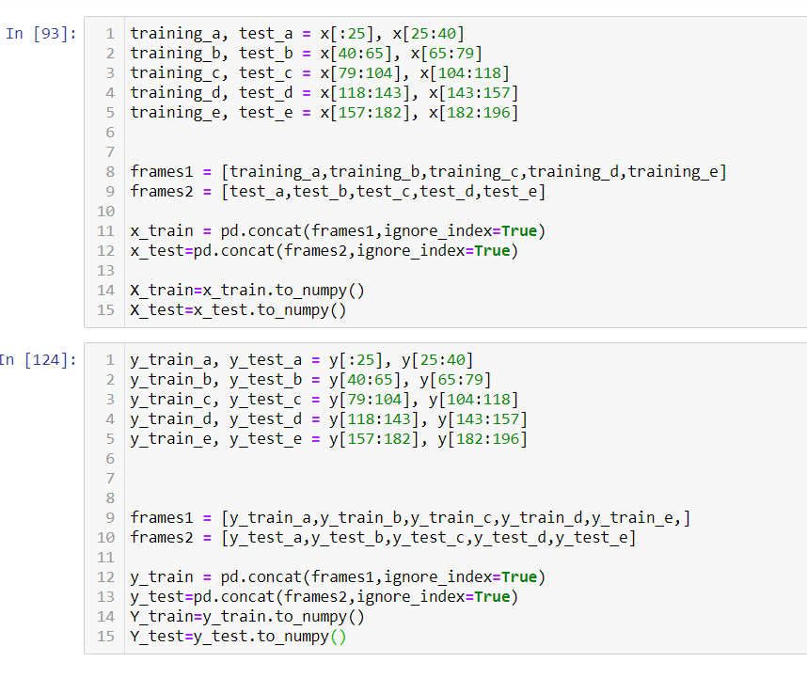

***2-)*** I used naive Bayes’ classifier where *p(xj*|C*i)*

are Bernoulli. The discriminant function is given in chapter 5.7 .

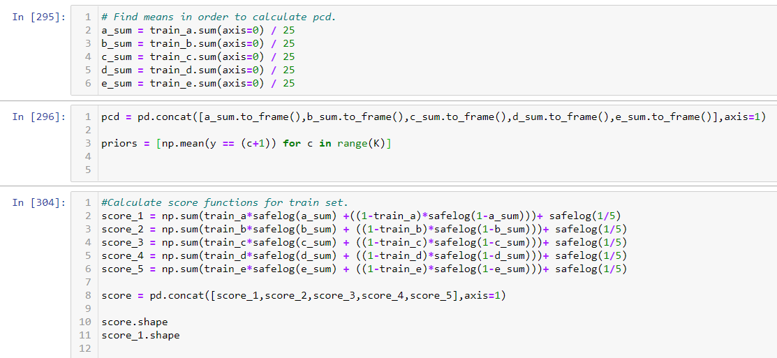

***3-)*** Finally , I calculated my confusion matrices for train and test sets using the classification rule I developed using parameters.

